Media Release

For Immediate Release 13 July, 2016

ANNOUNCING HAMLAN’S STUNNING NEW BOUTIQUE DEVELOPMENT
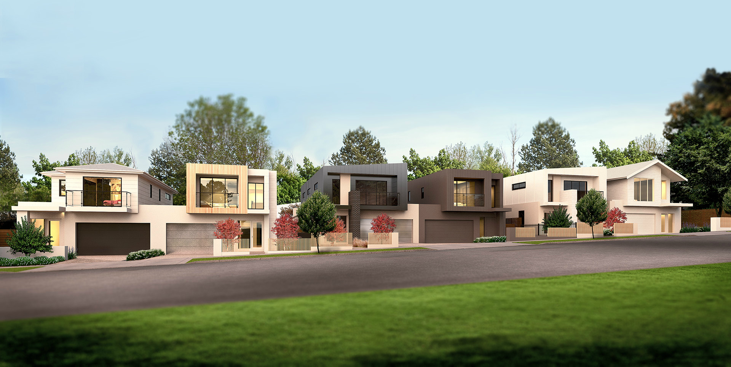This week Hamlan launches Frank Street, a groundbreaking new residential development in Newtown. Long dedicated to building homes for local lifestyles and landscapes, Hamlan has focused on unique design for this cohesive collection of six residences.
Frank Street blends traditional and contemporary urban architecture, with each residence enjoying a unique façade. Exterior finishes include standing seam zinc cladding, concrete, hardwood timber and modern glass. The result is a development that both matches and modernize its streetscape.
Hamlan’s General Manager, Andrew Carroll says “Modern Newtown is increasingly progressive in terms of residential requirements and architectural opportunities. The suburb attracts young professionals, families and empty-nesters. We created Frank Street to meet their evolving needs, whilst also contributing to the evolution of Newtown from a design perspective”.
Carroll continues, “We’ve focused on standout elements like dramatic entry voids, raked ceilings and clerestory windows. A key feature of each home is the zonable first floor, enabling space and privacy for children or guests. Frank Street is another great opportunity for Hamlan to demonstrate its architectural and building capabilities”.
The Architect
Frank Street was designed by Senior Architect, Brent Yttrup. With significant experience designing properties in Australia, Asia and Europe, Brent is motivated by sustainable design and construction. Brent has won several awards for innovation in sustainability and an international research fellowship. Frank Street is his first boutique development for Hamlan.
The Builder
Established in Anglesea in 1983, Hamlan was originally dedicated to rebuilding homes along the Great Ocean Road after the Ash Wednesday fires. In the 33 years since, it has played a significant role in the evolution of Geelong and the Surf Coast.
Hamlan's breadth of experience extends to creating breathtaking cliff-top homes and inner city living through to split levels and traditional homes. Hamlan is still family-owned and very proud to call Geelong home.

Frank Street comes with a choice of landscaping and residences start at $1.39m.

- ends -

Website: www.frankstreet.com.au
Facebook and Instagram: @hamlanhomes

For media enquiries please contact:
Bianca Clair at Hamlan
Ph: xxx

